Week 9

More Graphing | Graph $y={e^{-x}}^{2}$  $\frac{dy}{dx}={e^{-x}}^{2}*\frac{d}{dx}\left(-x^{2}\right)=-2xe^{-x^{2}}$  $\frac{d^{2}y}{dx^{2}}=\frac{d}{dx}\left(\frac{dy}{dx}\right)=\frac{d}{dx}\left(-2e^{-x^{2}}\right)$  $=\left(\frac{d}{dx}\left(-2x\right)\right)e^{-x^{2}}+\left(-2x\right)\frac{d}{dx} (e^{-x^{2}}$)  $=-2e^{-x^{2}}-2x\left(-2xe^{-x^{2}}\right)$  $=-2e^{-x^{2}}+4x^{2}e^{-x^{2}}$  $=\left(2x^{2}-1\right)2e^{-x^{2}}$  Critical Points  $\frac{dy}{dx}=-2xe^{-x^{2}}=0$  when $x=0$  $\frac{d^{2}y}{dx^{2}}=2\left(2x^{2}-1\right)e^{-x^{2}}=0$  when $2x^{2}-1=0$  Note that the domain of $y=e^{-x^{2}}$ (and of $\frac{dy}{dx}$ & $\frac{d^{2}y}{dx^{2}}$ too) is all of $(-∞, ∞)$  x $$\left(-∞, -\frac{1}{\sqrt{2}}\right)$$ $$-\frac{1}{\sqrt{2}}$$ $$\left(-\frac{1}{\sqrt{2}}, 0\right)$$ 0 $$\left(0, \frac{1}{\sqrt{2}}\right)$$ $$\frac{1}{\sqrt{2}}$$ $$\left(\frac{1}{\sqrt{2}}, ∞\right)$$  $$\frac{dy}{dx}$$ + + + 0 - - -  $$\frac{d^{2}y}{dx^{2}}$$ + 0 - - 0 +  y inc inc inc Abs Max dec dec dec  What does $\frac{d^{2}y}{dx^{2}}$ being + or –tell you about y? ( The change of the slope)  +: concave up  - : concave down  Horizontal Asymptotes  $\lim_{x→-∞}{e^{-x^{2}}}= \lim_{x→-∞}{\frac{1}{e^{x^{2}}}}→ 0$  $\lim_{x→∞}{e^{-x^{2}}}= \lim_{x→∞}{\frac{1}{e^{x^{2}}}}→ 0$  Vertical Asymptotes?  $y={e^{-x}}^{2}$ is defined & exists for all x so it can’t have vertical asymptotes  Intercepts  y-intercept: $x=1$  x-intercept: None  Draw the Graph:  $$y=e^{-x^{2}}$$  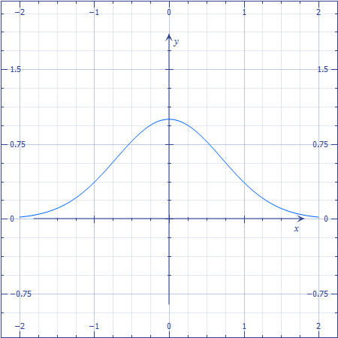  Points of Inflection:  $-\frac{1}{\sqrt{2}}$ & $\frac{1}{\sqrt{2}}$

Integration  Anti-derivatives & Integrals | Two Problems:  - Given $f’\left(x\right)$ what is$f(x)$?  - Given$y=g\left(x\right)$, what is the area between the graph and the x-axis for $a≤x≤b$?
Some anti-derivatives

Exponential Rule for anti-derivates
$\frac{dy}{dx}x^{k}, what is y=?$

$y=\frac{x^{k+1}}{k+1}$

When $k≠-1$

cause $\frac{dy}{dx}=\frac{d}{dx}\left(\frac{x^{k+1}}{k+1}\right)=\frac{\left(k+1\right)x^{k+1-1}}{k+1}=x^{k}$

$\frac{dy}{dx}=\frac{d}{dx}\left(\frac{x^{k+1}}{k+1}+c\right)=x^{k}+\frac{d}{dx}c=x^{k}+0=x^{k}$
c Could be any constant, so anti-derivatives are not unique.

When $k=-1$

$\frac{dy}{dx}=x^{-1}=\frac{1}{x}$
so $y=\ln\left(x\right)+c$

General Fact: If $F\left(x\right)$ is an anti-derivative of $f(x)$ then so is $F(x)+c$ for any c.

Sum Rule for anti-derivatives
If $F(x) \& G(x)$ are the anti-derivatives of $f(x) \& g(x)$ respectively, then the anti-derivated of $f(x)+g(x)$ is $F(x)+G(x)+c$.

Multiplication by constants rule for anti-derivaties
IF $F(x)$ is an anti-derivates of $f(x)$ and $g(x)=af(x)$ then $G\left(x\right)=aF\left(x\right)+c$ is an anti-derivative of $g(x)$.

Notation | We’ll denote the anti-derivative of $f(x)$ by $∫f\left(x\right)dx$  - $∫x^{k}dx=\frac{x^{k+1}}{k+1}+c$ if $k≠-1$  $∫x^{-1}dx=\ln\left(x\right)+c$  - $∫\left[f\left(x\right)+g\left(x\right)\right]dx=∫f\left(x\right)dx+∫g\left(x\right)dx$  - $∫af\left(x\right)dx=a∫f\left(x\right)dx$  - $∫\cos\left(x\right)dx=\sin\left(x\right)+c$  $∫\sin\left(x\right)dx=-\cos\left(x\right)+c$  - $∫e^{x}dx=e^{x}$  - $∫\ln\left(x\right)dx=$  $u=ln⁡(x)$ $u^{'}=\frac{1}{x}$  $v'=1$ $v=x$  $xlnx\left(x\right)-\int{\frac{1}{x}xdx=xln\left(x\right)}-x+c$

