Finding areas the hard way
The area under $y=3x+2$ (and the x-axis) for $0≤x≤4$

$$y=3x+2$$
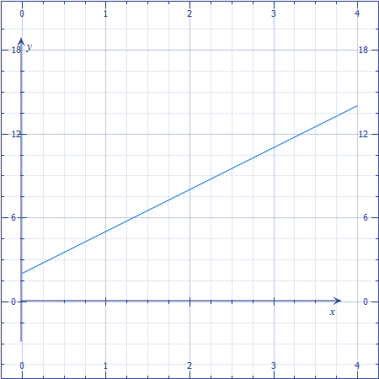
Area?
Rectangle + triangle
$2*4+\frac{1}{2}4*12=32$

The area under the parabola $y=x^{2}$ for $3≤x≤7$

$$y=x^{2}$$
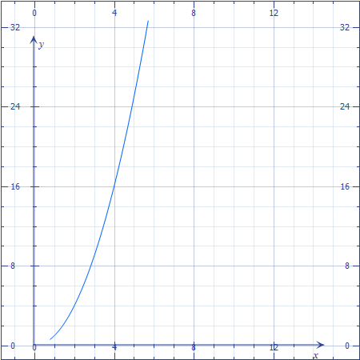

Area? (The easy way)
$\int_{3}^{7}{x^{2}dx=\frac{x^{2}+1}{2+1}}=\frac{1}{3}x^{3}|\begin{matrix}7 \\ 3\end{matrix}=\frac{1}{3}7^{3}-\frac{1}{3}3^{3}=\frac{343}{3}-\frac{27}{3}=\frac{316}{3}$

Area?(The hard way)
The general hard way is to approximate the region by a lot of thin rectangles and take the limit as they get infinitely thin...

Using the “Right-hand Rule”:
Split [3, 7] into n equal pieces – each will have width $\frac{7-3}{n}$

1st rectangle’s area = base x height = $\frac{7-3}{n}*{\left(3+\frac{7-3}{n}\right)}^{2}$
2nd rectangle’s area = base x height = $\frac{7-3}{n}*{\left(3+2\frac{7-3}{n}\right)}^{2}$
3rd rectangle’s area = base x height =$\frac{7-3}{n}*{\left(3+3\frac{7-3}{n}\right)}^{2}$
.
.
.
k^{th} rectangle’s are = base x height =$\frac{7-3}{n}*{\left(3+k\frac{7-3}{n}\right)}^{2}$

The sum of the areas of the rectangles $\left(\sum_{k=1}^{n}{\left(\frac{7-3}{n}\right){\left(3+k\frac{7-3}{n}\right)}^{2}}\right)$
So the area is actually the $\lim_{n→∞}\left(\sum_{k=1}^{n}{\left(\frac{7-3}{n}\right){\left(3+k\frac{7-3}{n}\right)}^{2}}\right)$

Solution:
$\lim_{n→∞}\left(\sum_{k=1}^{n}{\left(\frac{4}{n}\right){\left(3+\frac{4k}{n}\right)}^{2}}\right)$
$=\lim_{n→∞}\left(\sum_{k=1}^{n}{\left(\frac{4}{n}\right)\left(3^{2}+2\left(3\frac{4k}{n}\right)+{\left(\frac{4k}{n}\right)}^{2}\right)}\right)$
$=\lim_{n→∞}\left(\sum_{k=1}^{n}{\left(\frac{4}{n}\right)\left(9+\frac{24k}{n}+\frac{16k^{2}}{n^{2}}\right)}\right)$
$=\lim_{n→∞}\left(\sum_{k=1}^{n}{\left(\frac{36}{n}+\frac{96k}{n^{2}}+\frac{64k^{2}}{n^{3}}\right)}\right)$
$=\lim_{n→∞}\left(\left[\frac{36}{n}+\frac{96}{n^{2}}+\frac{64}{n^{3}}\right]+\left[\frac{36}{n}+\frac{96*2}{n^{2}}+\frac{64*2^{2}}{n^{3}}\right]+\left[\frac{36}{n}+\frac{96*3}{n^{2}}+\frac{64*3^{2}}{n^{3}}\right]+…+\left[\frac{36}{n}+\frac{96*n}{n^{2}}+\frac{64*n^{2}}{n^{3}}\right]\right)$
$=\lim_{n→∞}\left(\left[\frac{36}{n}+\frac{36}{n}+…+\frac{36}{n}\right]+\left[\frac{96*1 }{n^{2}}+\frac{96*2 }{n^{2}}+…+\frac{96*n }{n^{2}}\right]+\left[\frac{64*1^{2}}{n^{3}}+\frac{64*2^{2}}{n^{3}}+…+\frac{64*3^{2}}{n^{3}}\right]\right)$
$=\lim_{n→∞}\left(\left[\sum_{k=1}^{n}{\frac{36}{n}}\right]+\left[\sum_{k=1}^{n}{\frac{96k}{n^{2}}}\right]+\left[\sum_{k=1}^{n}{\frac{64}{n^{3}}k^{2}}\right]\right)$
$=\lim_{n→∞}\left(\frac{36}{n}\left[\sum_{k=1}^{n}{1}\right]+\frac{96}{n^{2}}\left[\sum_{k=1}^{n}{k}\right]+\frac{64}{n^{3}}\left[\sum_{k=1}^{n}{k^{2}}\right]\right)$
$=\lim_{n→∞}\left(\frac{36}{n}*n+\frac{96}{n^{2}}*\frac{n(n+1)}{2}+\frac{64}{n^{3}}*\frac{n\left(n+1\right)(2n+1)}{6}\right)$
$=\lim_{n→∞}\left(36+48*\frac{n+1}{n}+\frac{32}{3}*\frac{\left(n+1\right)(2n+1)}{n^{2}}\right)$
$=\lim_{n→∞}\left(36+48\left(\frac{n}{n}+\frac{1}{n}\right)+\frac{32}{3}\left(\frac{2n^{2}}{n^{2}}+\frac{3n}{n^{2}}+\frac{1}{n^{2}}\right)\right)$
$=\lim_{n→∞}\left(36+48\left(1+\frac{1}{n}\right)+\frac{32}{3}\left(2+\frac{3}{n}+\frac{1}{n^{2}}\right)\right)$
$=36+48\left(1+0\right)+\frac{32}{3}(2+0+0)$
$=84+\frac{64}{3}=\frac{252+64}{3}=\frac{316}{3}$
In real life we use The Fundamental Theorem of Calculus

- Area under $y=f\left(x\right)$ for $a≤x≤b=\int_{a}^{b}{f\left(x\right)dx=F\left(b\right)-F(a)}$ where F(x) is any anti-derivative of f(x) is $F^{'}\left(x\right)=f(x)$

Example: $f\left(x\right)=x$ for $-3≤x≤-1$
“The” anti-derivative of x is $\frac{x^{2}}{2}$.

$\int_{-3}^{-2}{xdx=\frac{x^{2}}{2}{\left.​\right|}_{-3}^{-2}=\frac{{\left(-2\right)}^{2}}{2}-\frac{{\left(-3\right)}^{2}}{2}=\frac{4}{2}-\frac{9}{2}=-\frac{5}{2}}$
The area below the x-axis is “negative area”.

The Fundamental Theorem of Calculus (version 1.0)
$\int_{a}^{b}{f\left(x\right)dx=F\left(b\right)-F(a)}$ whenever $F^{'}\left(x\right)=f(x)$

The Fundamental Theorem of Calculus (version 2.0)
If $F\left(x\right)=\int_{c}^{x}{F\left(t\right)dt}$
Then $F^{'}\left(x\right)=f(x)$

Order properties of the definite integral:
- $\int_{a}^{a}{f\left(x\right)dx}=0$

- $\int_{a}^{b}{f\left(x\right)dx+\int_{b}^{c}{f\left(x\right)dx}}$
$=\int_{a}^{c}{f\left(x\right)dx}$

- $\int_{b}^{a}{f\left(x\right)dx=\int_{a}^{b}{-f\left(x\right)dx}}$
$\int_{a}^{b}{f\left(x\right)dx+\int_{b}^{a}{f\left(x\right)dx=\int_{a}^{a}{f\left(x\right)dx=0}}}$

- If $g\left(x\right)≤f(x)$ on $[a, b]$
Then
$\int_{a}^{b}{g\left(x\right)dx≤\int_{a}^{b}{f\left(x\right)dx}}$

- Suppose $m≤f\left(x\right)≤M$
For x in $[a, b]$. Then
$m\left(b-a\right)≤\int_{a}^{b}{f\left(x\right)dx}≤M(b-a)$

$\int_{a}^{b}{mdx≤\int_{a}^{b}{f\left(x\right)dx≤\int_{a}^{b}{Mdx}}}$
$=m\int_{a}^{b}{1dx}≤\int_{a}^{b}{f\left(x\right)dx≤M\int_{a}^{b}{1dx}}$
$=mx{\left.​\right|}_{a}^{b}≤\int_{a}^{b}{f\left(x\right)dx}≤Mx{\left.​\right|}_{a}^{b}$
$=mb-ma≤\int_{a}^{b}{f\left(x\right)dx}≤Mb-Ma$

- $\left|\int_{a}^{b}{f\left(x\right)dx}\right|≤\int_{a}^{b}{\left|f\left(x\right)\right|dx}$

Why? Because
$-\left|f\left(x\right)\right|≤f\left(x\right)≤\left|f\left(x\right)\right|$

So
$-\int_{a}^{b}{\left|f\left(x\right)\right|dx}≤\int_{a}^{b}{f\left(x\right)dx}≤\int_{a}^{b}{|f(x)|dx}$

Ex: $f\left(x\right)=e^{-x^{2}}$
What can we find out about$\int_{2}^{5}{e^{-x^{2}}dx}$?

We can’t easily evaluate this, but we can estimate it:
$0≤e^{-x^{2}}≤1$
Because $e^{-x^{2}}=\frac{1}{e^{x^{2}}}$

$0∙(5-2)≤\int_{2}^{5}{e^{-x^{2}}dx}≤1∙(5-2)$  $e^{-5^{2}}≤e^{-x^{2}}≤e^{-2^{2}}$  $\frac{1}{e^{25}}\left(5-2\right)≤\int_{2}^{5}{e^{-x^{2}}dx}≤\frac{1}{e^{4}}(5-2)$  $\frac{3}{e^{25}}≤\int_{2}^{5}{e^{-x^{2}}dx}≤\frac{3}{e^{4}}$ | $$e^{-x^{2}}$$  